**AI Based Diabetes Prediction System**

**BATCH MEMBER : K.Aadhi surya -731221104001**

**K.Chandra Prakash -731221104008**

**G.Madhan -731221104022**

**P.Pandiya raj -731221104027**

**V.Bambavasan -731221104007**

**Phase 4: Development Part 2**

1. Selecting Support Vector Machines (SVM):

Support Vector Machines are a type of supervised machine learning algorithm used for classification and regression tasks. SVM aims to find a hyperplane that best separates data points of different classes while maximizing the margin between them. The choice of SVM for your diabetes prediction system is based on its ability to handle both linear and non-linear relationships in the data.

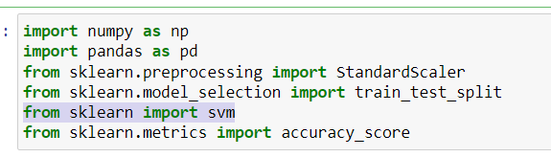

2. Training the SVM Model:

2.1 Data Preparation:

You need a labeled dataset where each instance has features (like blood sugar levels, BMI, age, etc.) and a corresponding label indicating whether the individual has diabetes or not.

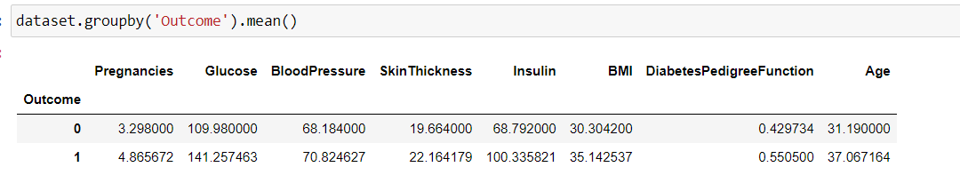

2.2 Splitting Data:

Divide your dataset into training and validation sets. The training set is used to train the model, and the validation set is used to evaluate its performance.

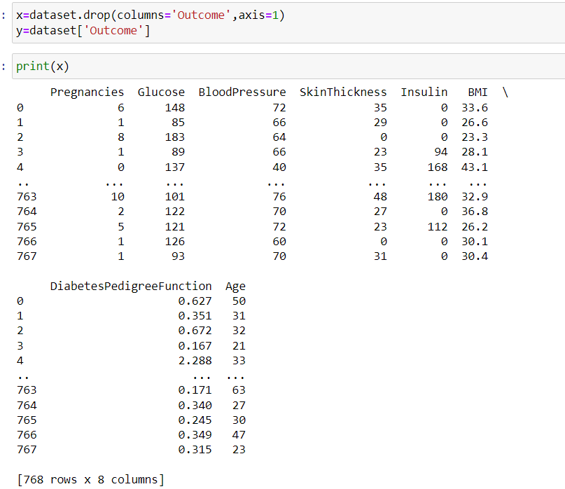

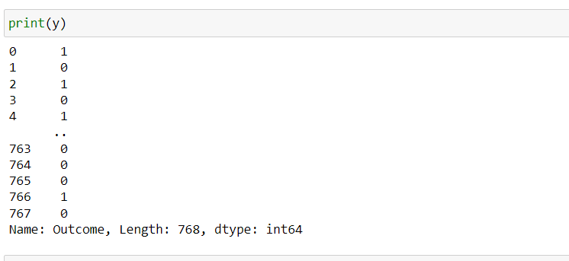

2.3 Feature Scaling:

SVMs are sensitive to the scale of features, so it's often beneficial to scale them to a standard range (e.g., using Min-Max scaling or standardization). 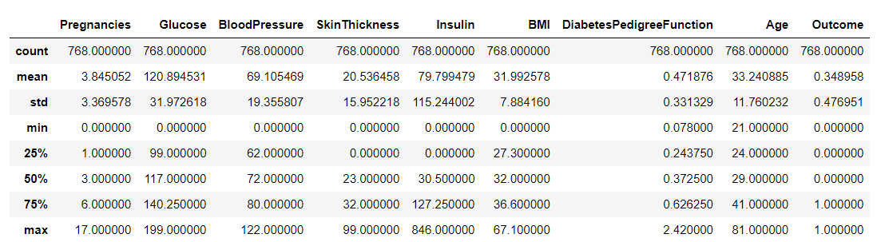

2.4 Training the SVM:

Feed the training data into the SVM algorithm. The SVM will adjust its parameters to find the hyperplane that best separates the data points of different classes.

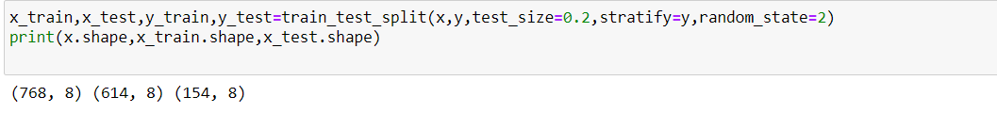

3. Evaluating its Performance:

3.1 Validation Set:

Use the validation set (data the model hasn't seen before) to assess the performance of the trained SVM.

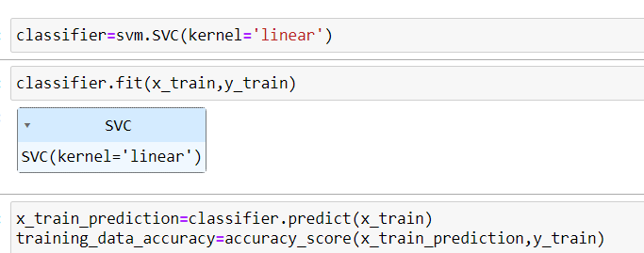

3.2 Metrics:

Compute metrics like accuracy, precision, recall, and F1 score to evaluate how well the SVM is predicting diabetes.

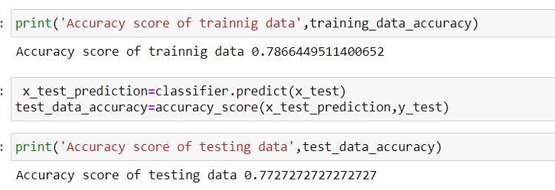

3.3 Visualization:

Optionally, you can visualize the decision boundary created by the SVM to understand its classification behavior .

Conclusion:

By following these steps, you'll have a trained SVM model for diabetes prediction. Keep in mind that the effectiveness of the model may depend on the characteristics of your dataset and the hyperparameters chosen for the SVM.